A000-Asia-China-Hongshan Culture-Jade Double Boar-Three-hole device-1800 BCE

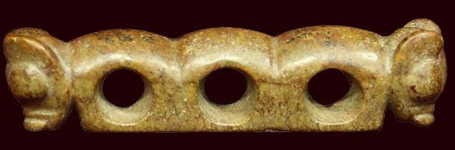

Asia-China-Hongshan Culture-Jade Double Boar-Three-hole device-1800 BCE

**Case No.: 5**

**Accession No.**

**Formal Label:** Asia-China-Hongshan Culture-Jade Double Boar-Three-hole device-1800 BCE

**Display Description:**

This device is a symbolic representation of the habitat of the wild boar upon which the Hongshan culture depended. The humps above the circles are meant to indicate the mountainous terrain in which he boar made its burrows and the holes represented the burrows. This symbolism has largely gone unnoticed or misinterpreted but this is because the carriers of the Hongshan tradition have not been contacted directly. This information comes from an expedition to Hongshan territory where elder folk divulged the symbolism in 1978.

**Accession Number:**

**LC Classification:**

**Date or Time Horizon:**

**Geographical Area:**

**Map:**

**GPS coordinates:**

**Cultural Affiliation:**

**Media:**

**Dimensions:**

**Weight:**

**Condition:**

**Provenance:**

**Discussion:**

紅山文化--玉雙獸 --三孔器-Hóngshān wénhuà--yù shuāng shòu--sān kǒng qì黄山 Huángshān



五猴山 原 Wǔ hóu shānyuán

jade double-pig first three-hole device) collected by the San Guan Dian Zi Cun, Lingyuan City, Liaoning Province in 1979 (or unearthed from the Tomb of No. 2 in Chengzishan). Length 9.2, height 2.8, thickness 1.8 cm. Three rows of large round hole body, a hole diameter of 1.9 cm. The central hole has two small perforations through the bottom of the hole, the two sides of each hole has a small hole through the bottom (see Figure 3).

出土器之一是1979年辽宁省凌源市三官甸子村采集(或城子山2号墓遗址出土)的一件兽首三孔玉器（或玉雕双猪首三孔器）。器长9.2、高2.8、厚1.8厘米。器身三个横列大圆孔，孔径为1.9厘米。中央一孔有两个小穿孔透底面，其两侧两孔各有一小孔穿底面（见图三）。

One of the excavations was collected by San Guan Dian Zi Cun in Lingyuan City, Liaoning Province in 1979

(Or Chengzishan 2 Tomb ruins unearthed) a beast first three holes jade (or jade double pig first three holes). Length 9.2, height 2.8, thickness 1.8 cm. Three rows of large round hole body, a hole diameter of 1.9 cm. The central hole has two small perforations through the bottom of the hole, the two sides of each hole has a small hole through the bottom (see Figure 3)

[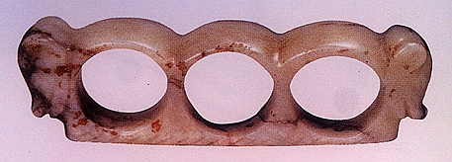](http://photo.blog.sina.com.cn/showpic.html#blogid=a3afa4c60102whkw&url=http://album.sina.com.cn/pic/002ZQLl4gy700yfLs9Z13)

**References:**